**Basic Electronics (Practice questions)**

1. Find IB, IC, VCE, VC, VB, VE in the circuit given below, if Vi =5V.

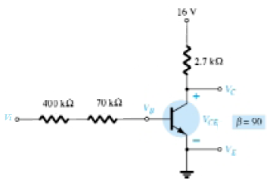

1. Find IB, IC, VC, VE, VCE, VB in the circuit given below, if Vi =10V.

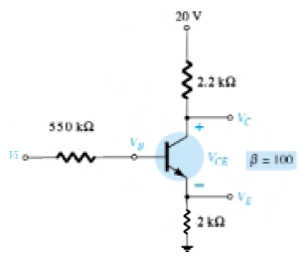

1. Determine whether or not the transistor is saturated for the following values: $β$ = 125, VBB =1.5V, RB = 6.8kΩ, RC = 180Ω and VCC =12V and VCE = 0.2V.

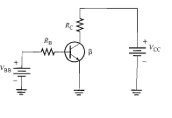

1. If $β$ =150 and VCE=0.2V for each transistor, then find out which 2-input logic gate is shown below.

**Note: Use high logic H = 5V and for low logic L = 0V**

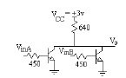

1. If $β$ =150 and VCE=0.2V for each transistor, then find out which 2-input logic gate is shown below.

**Note: Use high logic H = 5V and for low logic L = 0V**

